Dashboard Page - Functional Documentation

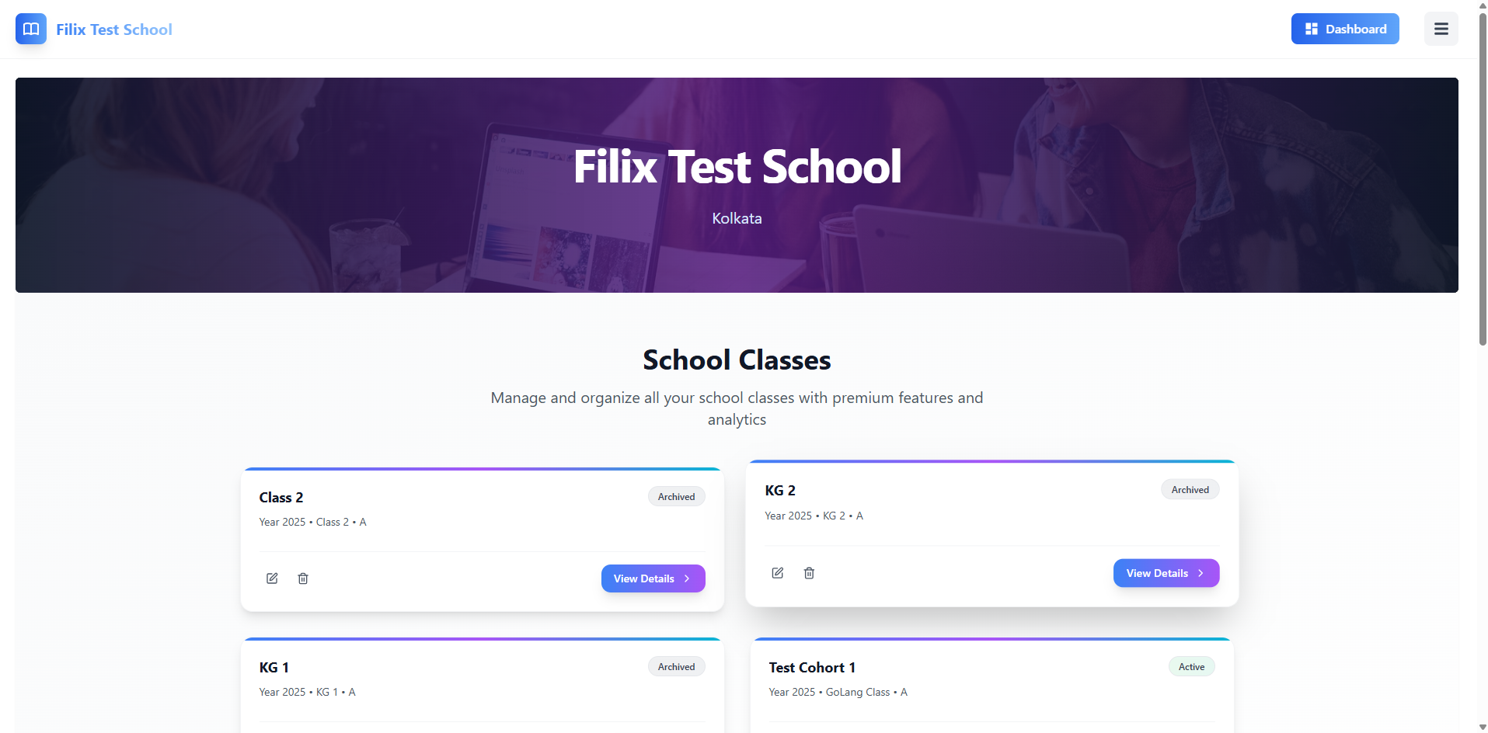

Overview
The Dashboard Page serves as the main interface for managing and organizing all classes, teachers, students, and school-related functions. It provides quick access to various sections for managing classes, viewing reports, and more, using intuitive buttons and filters.

Page Header and Navigation
- School Name: The page header displays the name of the school (e.g., "Filix Test School") along with the location (e.g., "Kolkata").
- Page Title: "School Classes" – Indicates that the user is currently on the School Classes page.
- Role Information: Displays the user's role, which is typically "Super Admin" in this case, along with easy access to their profile.

Class Management Section
- Class Cards: The dashboard displays a list of active and archived school classes in card format. Each card contains:
  - Class Name: The name of the class (e.g., "Class 2", "KG 1").
  - Year & Section Information: The year and section associated with the class (e.g., "Year 2025 • Class 2 • A").
  - Status: Indicates whether the class is Active, Archived, or Pending.
  - Action Buttons: Each class card has the following options:
    - View Details: Takes the user to a more detailed view of the class.
    - Edit: Allows editing of class information (e.g., change name, section).
    - Delete: Removes the class from the system.
- Class Status: Classes are labeled as Active, Archived, or Pending. This status is color-coded to provide clear visual distinctions.

Class Overview
- Manage Teachers:
  - Allows the user to view and manage all teachers within the school. The section shows the total number of teachers, and an option to navigate to the "Manage Teachers" page.
- Manage Students:
  - Allows the user to view and manage all student profiles. The section displays the total number of students, and an option to navigate to the "Manage Students" page.
- Reports Section:
  - Provides quick access to school reports and analytics for tracking performance, attendance, and other academic data.

Action Buttons and Links
- Edit or Delete Classes:
  - This button allows the user to edit or delete a new school class by filling out a form with the necessary details.
- View All Classes:
  - Displays a complete list of all classes, including archived, active, and pending.

Teacher Management Page - Functional Documentation

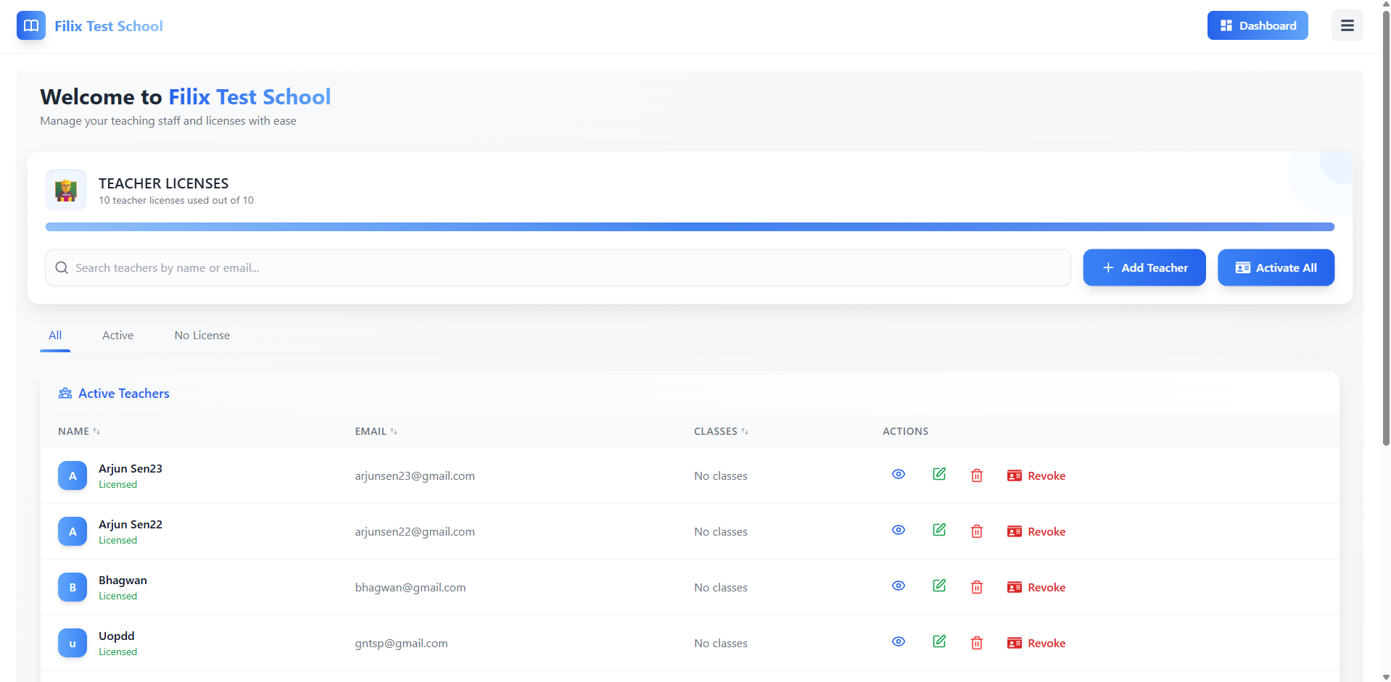

Overview
The Teacher Management Page allows the Super Admin to manage and organize teacher licenses, including assigning or revoking licenses, viewing teacher details, and adding new teachers. It provides the ability to track teacher statuses, classes, and license validity.

Page Header and Navigation
- Page Title: "Welcome to Filix Test School" – The page title includes the school's name for easy identification.
- Teacher Licenses Statistics: Displays the total number of teacher licenses available (e.g., "10 teacher licenses used out of 10").
  - Progress Bar: Shows the percentage of teacher licenses currently in use.
- Search Bar: Allows the user to search for teachers by their name or email for easy filtering.

Teacher Management Section
- Filter Options:
  - All: Displays all teachers, whether they have an active license or not.
  - Active: Displays only teachers with active licenses.
  - No License: Displays teachers who do not have a license.
- Teacher List: Displays a table of teachers with the following columns:
  - Name: The teacher's name (e.g., "Arjun Sen23").
  - Email: The teacher's registered email address.
  - Classes: Displays the classes associated with the teacher (e.g., "No classes" if no classes are assigned).
- Action Buttons for each teacher:
  - View: Opens a detailed view of the teacher's profile and license information.
  - Edit: Allows editing of teacher details or reassigning the teacher to classes.
  - Delete: Removes the teacher from the system.
  - Revoke: Revokes the teacher's license.

Action Buttons and Links
- Add Teacher: Opens a form to add a new teacher to the system. This button is located at the top-right section of the page.
- Activate All: Activates all available teacher licenses, making them ready for assignment.

License Management
- License Status: For each teacher, the license status is displayed as either Licensed or No classes depending on whether the teacher has been assigned a license and a class.
- License Revoke: If the teacher has a license, the "Revoke" option allows the Super Admin to remove or revoke the teacher's license, ensuring it cannot be used further.

Student Management Page -Functional Documentation
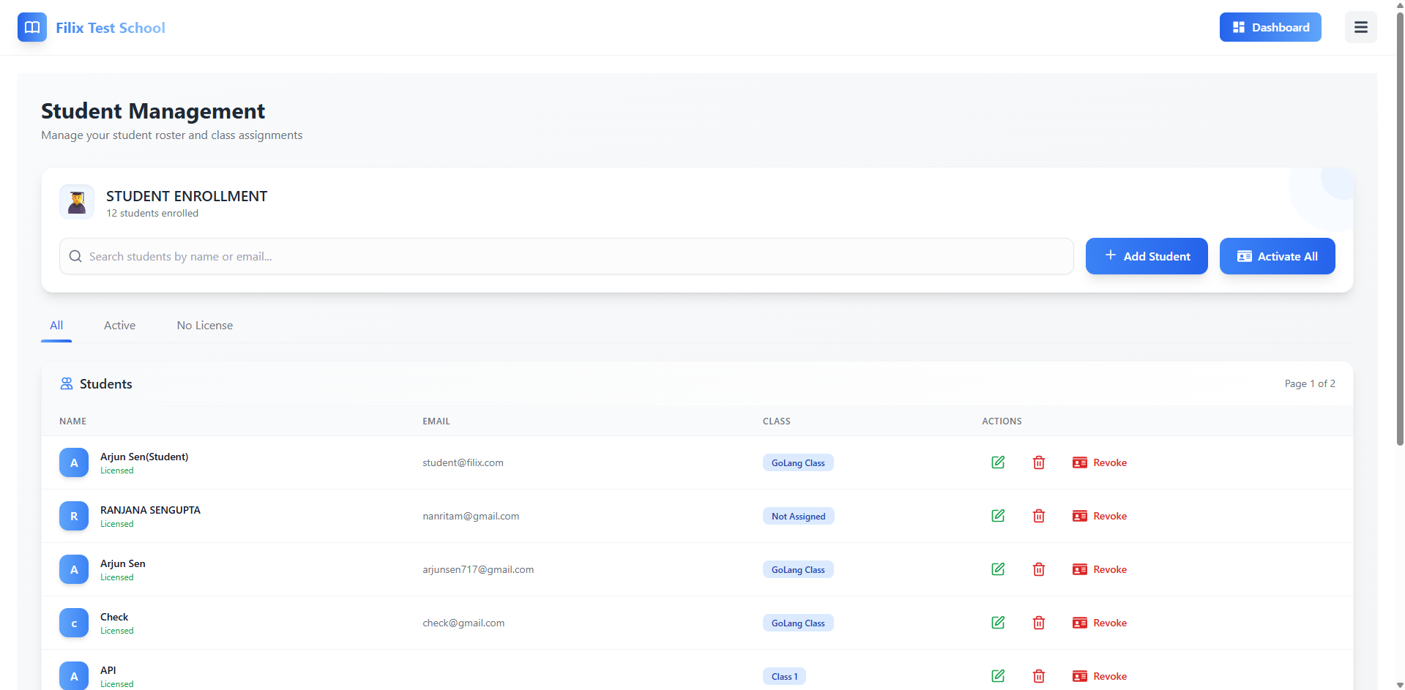

Overview
The Student Management Page allows the Super Admin to manage the student roster, view their class assignments, and track their license status. This page offers features for enrolling students, activating their licenses, and editing or revoking student details.

Page Header and Navigation
- Page Title: "Student Management" – Indicates that the user is currently on the Student Management page.
- Student Enrollment Statistics: Displays the total number of students enrolled in the school (e.g., "12 students enrolled").
- Search Bar: Allows the Super Admin to search for students by name or email for easy filtering.

Student Management Section
- Filter Options:
  - All: Displays all students, including those with and without licenses.
  - Active: Displays only students with active licenses.
  - No License: Displays students who do not have a license assigned.
- Student List: Displays a table of students with the following columns:
  - Name: The student's name (e.g., "Arjun Sen").
  - Email: The student's registered email address.
  - Class: The class the student is assigned to (e.g., "GoLang Class", "Not Assigned").
- Action Buttons:
  - View: Opens a detailed view of the student's profile and class assignments.
  - Edit: Allows the Super Admin to edit student details or assign/remove classes.
  - Delete: Removes the student from the system.
  - Revoke: Revokes the student’s license, making it inactive.

Action Buttons and Links
- Add Student: Located at the top-right, allows the Super Admin to add new students to the system.
- Activate All: Activates licenses for all students, making their licenses valid for class assignments.

License Management
- License Status: The student license status is displayed (e.g., "Licensed", "Not Assigned").
  - Revoke License: Allows the Super Admin to remove the student’s license, revoking access to their assigned class.

Cohort Management Page Documentation

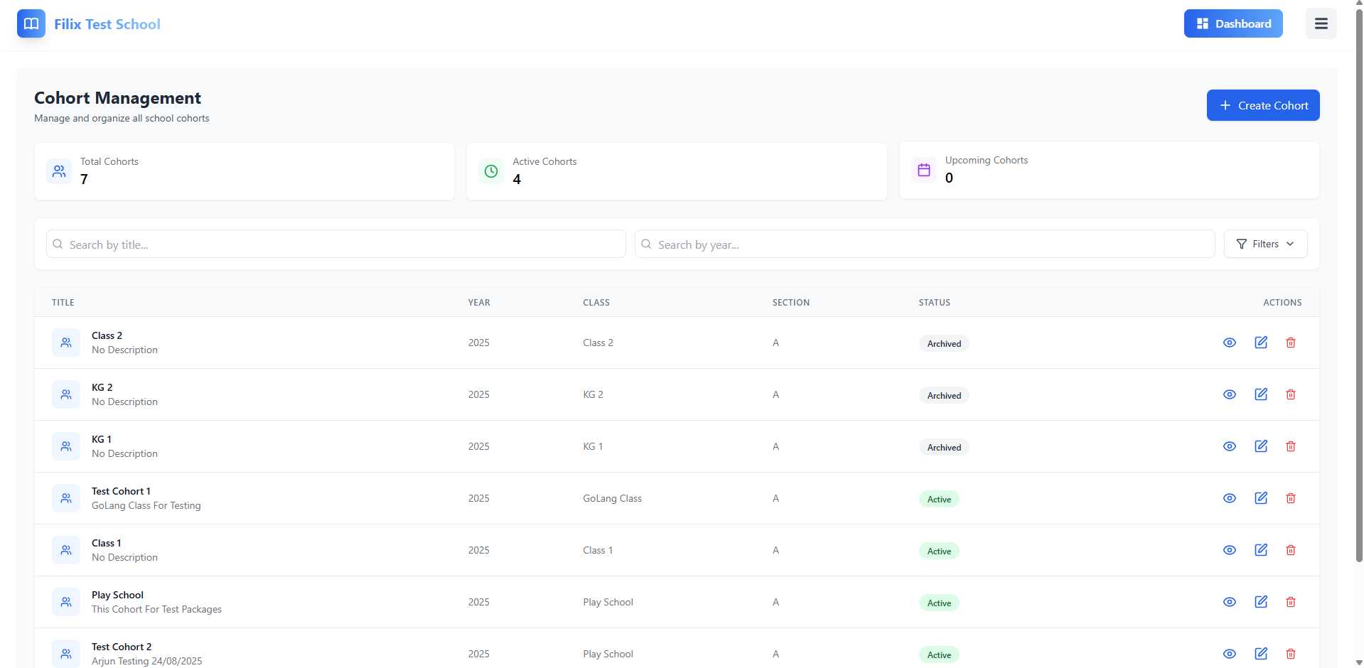

Overview
The Cohort Management Page is designed for managing and organizing cohorts (groups of students) based on the year, class, and section. It allows the Super Admin to view, edit, and manage active, archived, and upcoming cohorts for the school.

Page Header and Navigation
- Page Title: "Cohort Management" – Indicates that the user is currently on the Cohort Management page.
- School Name: Displays the name of the school (e.g., "Filix Test School").
- Cohort Statistics: Displays the total number of cohorts, the number of active cohorts, and the number of upcoming cohorts (e.g., "Total Cohorts: 7", "Active Cohorts: 4", "Upcoming Cohorts: 0").
- Search Bar: Allows the Super Admin to search for cohorts by title or year.
- Filters: Filters the list of cohorts based on status (active, archived, etc.).

Cohort List Section
- Cohort Cards: Displays a list of cohorts in a table format with the following columns:
  - Title: The name or title of the cohort (e.g., "Class 2", "Test Cohort 1").
  - Year: The year associated with the cohort (e.g., "2025").
  - Class: The class or subject associated with the cohort (e.g., "Class 1", "GoLang Class").
  - Section: The section of the cohort (e.g., "A").
  - Status: The status of the cohort, which is visually distinguished by color (e.g., Active in green, Archived in grey).
- Action Buttons:
  - View: Opens the detailed view of the cohort, where more information can be reviewed.
  - Edit: Allows the Super Admin to edit cohort details, including title, class, and status.
  - Delete: Removes the cohort from the system entirely.

Create Cohort
- Create Cohort Button:
  - Located in the top-right corner, this button opens a form to create a new cohort with options to assign a title, year, class, and section.

Cohort Status
- Active Cohorts:
  - Displays cohorts that are currently active and in progress.
- Archived Cohorts:
  - Displays cohorts that are no longer active or have completed their term. These cohorts are listed with the "Archived" status.

Session Management Page - Functional Documentation

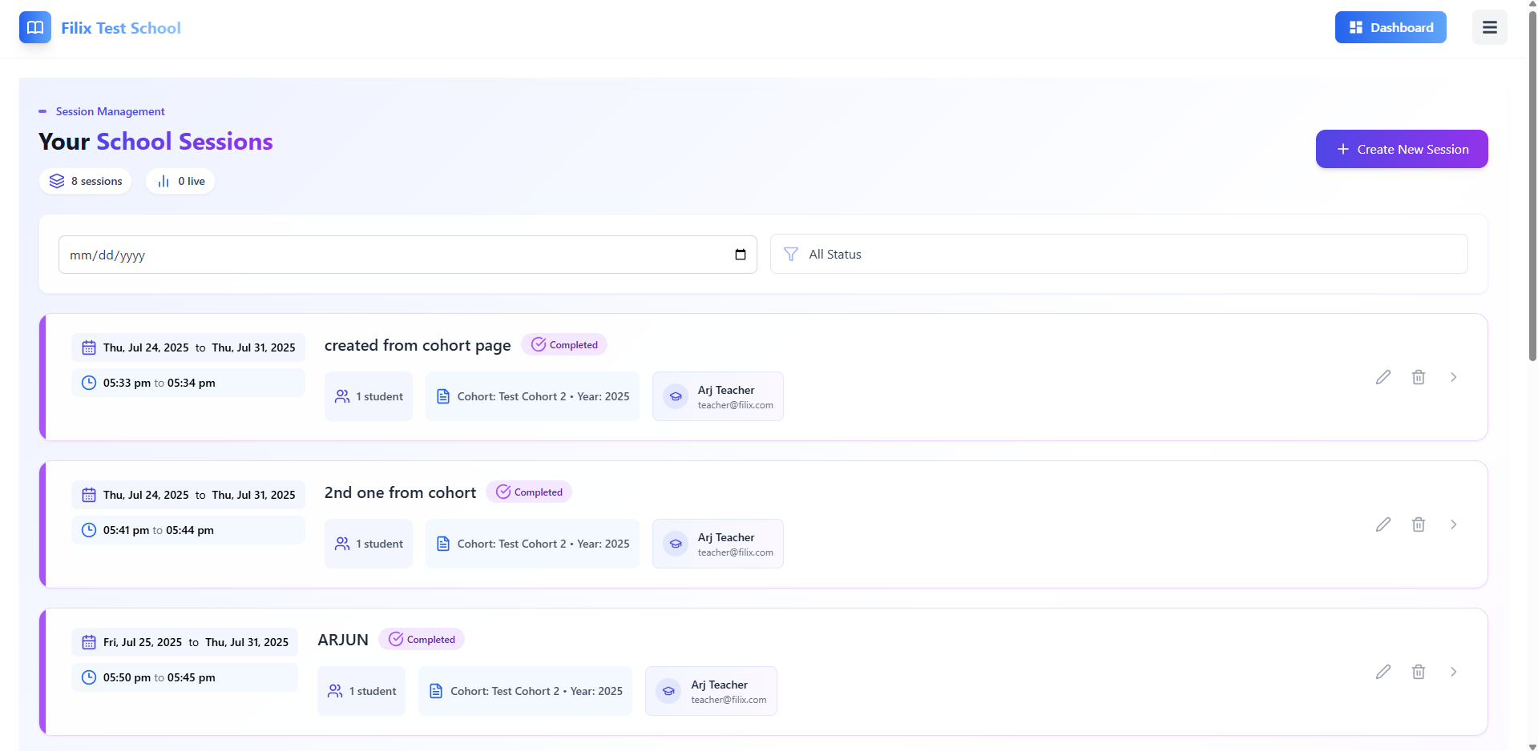

Overview
The Session Management Page allows the Super Admin to view, manage, and organize all school sessions. It provides easy access to session details, including dates, teacher assignments, status, and the ability to create or edit sessions. The page also includes filters to search and manage sessions by status, date, and cohort.

Page Header and Navigation
- Page Title: "Session Management" – Indicates that the user is currently on the session management page.
- School Name: Displays the name of the school (e.g., "Filix Test School").
- Session Statistics:
  - Total Sessions: Displays the total number of sessions (e.g., "8 sessions").
  - Live Sessions: Displays the number of live sessions (e.g., "0 live").
- Search Bar: Allows the user to search sessions by date, title, or cohort name.
- Filters: Filter sessions by their status (e.g., "Completed", "Active", etc.).

Session List Section
- Session Cards: Displays a list of sessions in a table format with the following columns:
  - Date: The date range for the session (e.g., "Thu, Jul 24, 2025 to Thu, Jul 31, 2025").
  - Time: The start and end time of the session (e.g., "05:33 pm to 05:34 pm").
  - Title: The title or description of the session (e.g., "created from cohort page").
  - Number of Students: Indicates how many students are part of the session (e.g., "1 student").
  - Cohort: The cohort associated with the session (e.g., "Cohort: Test Cohort 2 – Year: 2025").
  - Teacher: The name of the teacher assigned to the session (e.g., "Arj Teacher").
- Action Buttons for each session:
  - Edit: Allows the user to edit session details, such as title, time, and teacher.
  - Delete: Removes the session from the system.
  - Arrow: Allow the user to view the details of each session.
- Session Status:
  - Completed: Sessions that have already been finished are marked with a completed status.
  - Active: Sessions that are currently ongoing or live.

Create New Session
- Create New Session Button:
  - Located at the top-right corner, allows the user to create a new session, including selecting the date, time, teacher, and cohort for the session.

Licenses Page - Functional Documentation
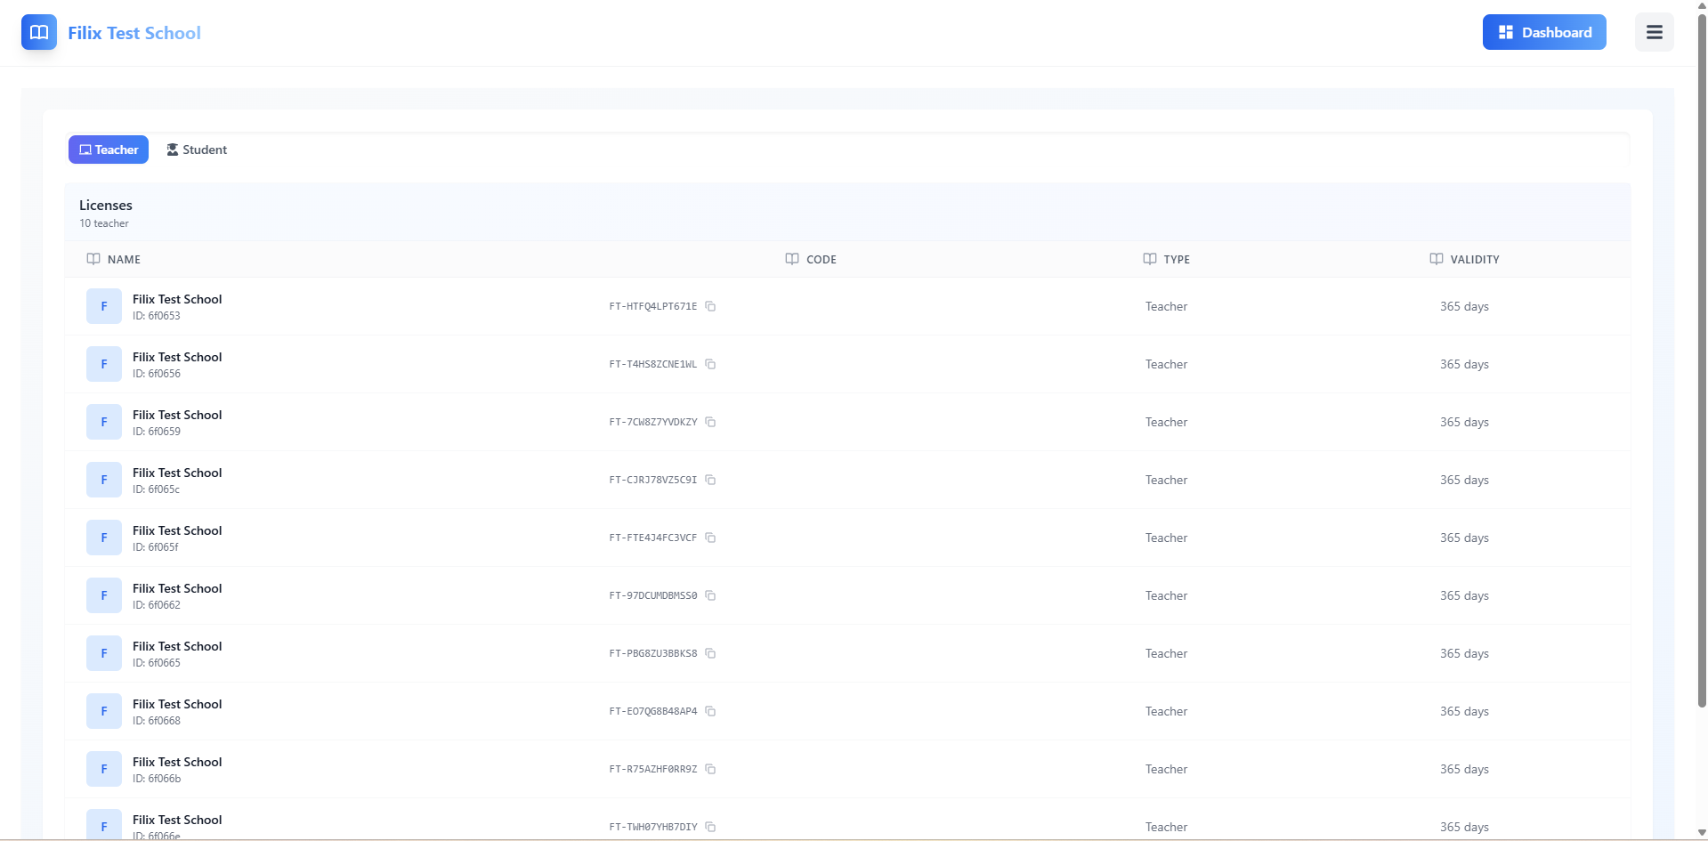

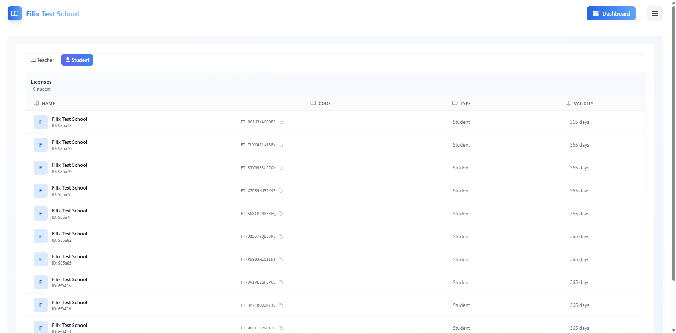

Overview
The Licenses Page allows the Super Admin to manage the licenses for both teachers and students. It provides the ability to view and organize licenses, including details such as the license code, type, validity, and associated school. The page offers clear visual distinctions between teacher and student licenses, allowing for easy navigation and management.

Page Header and Navigation
- Page Title: "Licenses" – Indicates that the user is currently on the License Management page.
- School Name: Displays the name of the school (e.g., "Filix Test School").
- License Type Tabs:
  - Teacher: Clicking on this tab shows the list of teacher licenses.
  - Student: Clicking on this tab shows the list of student licenses.
- Search Bar: Allows the user to search for licenses by name or license code.

License List Section
- Teacher License List: Displays a list of teacher licenses with the following columns:
  - Name: The name of the licensed entity (e.g., "Filix Test School").
  - Code: The unique identifier code for the license (e.g., "FT-HTFQ4LPT671E").
  - Type: The type of the license (e.g., "Teacher").
  - Validity: The duration for which the license is valid (e.g., "365 days").
- Student License List: Displays a similar list for student licenses, showing:
  - Name: The name of the licensed entity (e.g., "Filix Test School").
  - Code: The unique identifier code for the student license.
  - Type: The type of the license (e.g., "Student").
  - Validity: The duration for which the license is valid (e.g., "365 days").

Students' Report Page - Functional Documentation

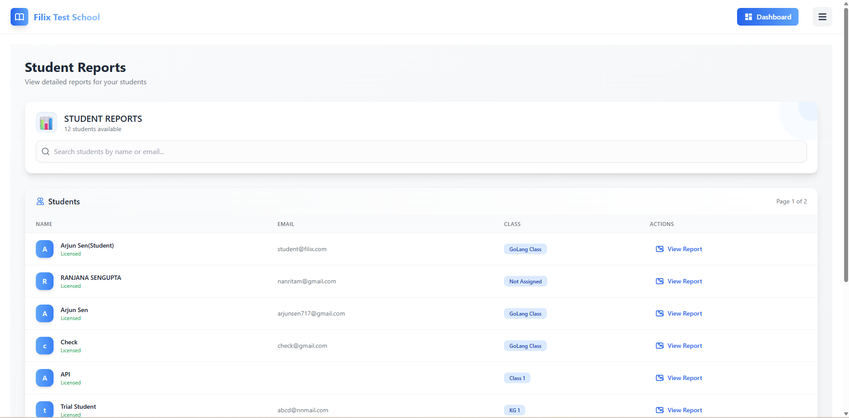

Overview:
The Student Reports page allows administrators and teachers to view detailed reports for students in their school. The report contains comprehensive data on student progress, competencies, skills, and more.

1. Header Section:
- The page header includes:
  - School Name: Displayed at the top-left.
  - Student Reports Title: Clearly indicating the page functionality ("Student Reports").
  - Search Bar: Located below the title, enabling users to search for students by name or email.
  - Action Button (View Report): Each student record has a "View Report" button to access the detailed report.

2. Main Content Section (Student List):
- Student Information Table: The main section lists students enrolled in the school with the following columns:
  - Name: Displayed for each student.
  - Email: Student’s email address.
  - Class: Class assigned to the student (e.g., "GoLang Class").
  - Actions: A "View Report" button next to each student's name allows users to access their detailed reports.

3. View Report Modal (When "View Report" is Clicked):
- Upon clicking the "View Report" button, a modal window appears with the following features:
  - Cohort Selection Dropdown:
    - A dropdown menu allows the user to select the cohort for the report (e.g., Class 1, Test Cohort 1, etc.).
    - Cohort Dropdown:
      - Users can choose a cohort from the available list of cohorts such as "Class 2 (2025)", "GoLang Class", "Play School (2025)", etc.
  - After selecting the cohort, the detailed student report will be shown, including tracking information and analytics.

4. Student Report Details:
- Once a cohort is selected, detailed progress data for the student is presented, including:
  - Competency Tracker: Shows competencies achieved, either in absolute or relative terms.
  - Skill Tracker: Skill development visualized based on selected competencies.
  - Activity History: Displays details about the activities undertaken by the student (e.g., "Test", "Assignment 1").
  - Competency Growth: Graphical representation of student progress over time.
  - Skill Growth: Displays growth based on various skills tracked.
  - Test Performance Analytics:
    - Total Attempts: Number of tests attempted by the student.
    - Average Score: The student's average score across all tests.
    - Highest/Lowest Score: The highest and lowest test scores achieved.
    - Performance Trend: Displays the student’s trend over time.
    - Progress Indicators: Shows overall progress, top strengths, and areas to improve.

Themes Page - Functional Documentation

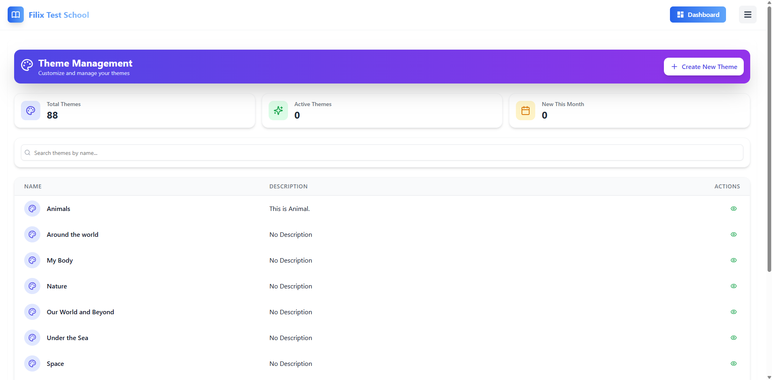

Overview:
The Themes Management page is designed to allow users (e.g., administrators or teachers) to manage and organize various themes for the school curriculum. Themes are used to categorize educational content, making it easier to organize and assign lessons.

1. Header Section:
- Title: The title "Theme Management" at the top clearly indicates the page's function.
- Action Button (Create New Theme): Users can create new themes by clicking this button. The button is prominently displayed in blue at the top-right corner of the page.
Filters and Stats:
- Total Themes: The number of themes in the system is displayed on the left, showing the total number.
- Active Themes: Shows the number of active themes.
- New This Month: Displays the count of new themes added in the current month.

2. Search Functionality:
- A search bar is located just under the header. Users can search for themes by name.

3. Themes Table:
- Table Columns:
  - Name: The name of each theme is displayed here (e.g., "Animals", "Around the world", etc.).
  - Description: Shows a brief description of the theme, where available.
  - Actions: This column provides options for each theme:
    - View: Allows the user to view more details about the theme.
- The themes are listed with their names and descriptions. If no description is provided, the field shows "No Description".
Example Themes:
- Animals: This theme is associated with animals and is described as "This is Animal."
- Around the world: No description is provided for this theme.
- My Body: No description is provided for this theme.

4. Theme Management Actions:
- Create New Theme: Clicking the "Create New Theme" button allows users to create a new theme.
- Actions on Individual Themes:
  - View: This button allows users to view more information or manage the selected theme.

Chapters Page - Functional Documentation
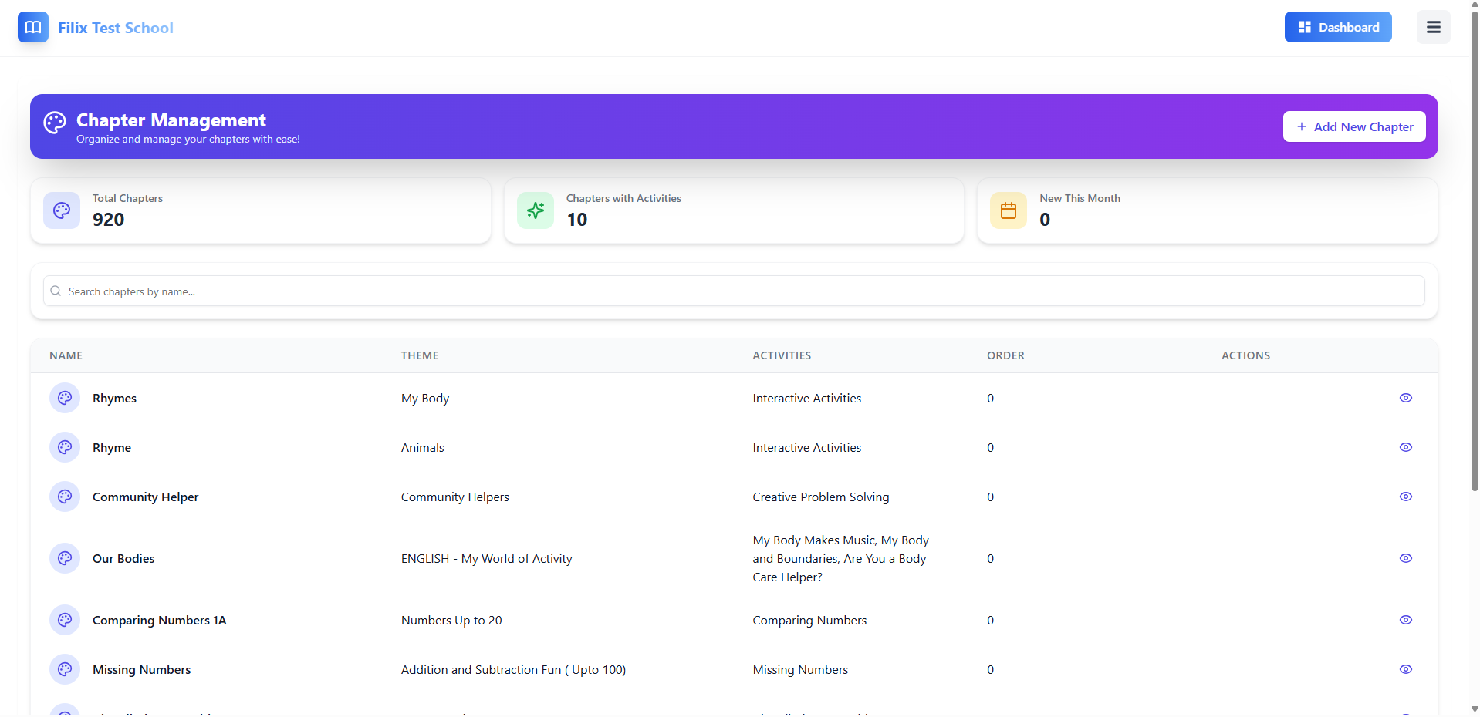

Overview:
The Chapter Management page is designed to allow users (e.g., school administrators and teachers) to manage, organize, and view educational chapters. Chapters are fundamental components that categorize different topics and are linked to specific themes and activities.

1. Header Section:
- Title: The title "Chapter Management" clearly indicates the purpose of this page, i.e., managing and organizing chapters.
- Action Button (Add New Chapter): Users can create new chapters by clicking this button. This button is located in the top-right corner, which shows “Add New Chapter".
Filters and Stats:
- Total Chapters: Displays the total number of chapters in the system.
- Chapters with Activities: Shows the number of chapters that have activities linked to them.
- New This Month: Indicates how many new chapters have been added in the current month.

2. Search Functionality:
- A search bar is available for users to search for chapters by name. This makes it easier to find specific chapters, especially when there are many.

3. Chapters Table:
- Table Columns:
  - Name: The name of each chapter is listed here, such as "Rhymes", "Community Helper", etc.
  - Theme: The theme associated with each chapter is displayed. Examples include "My Body", "Animals", "Community Helpers".
  - Activities: Lists the activities associated with each chapter, such as "Interactive Activities", "Creative Problem Solving", etc.
  - Order: This column shows the order or sequence number for the chapter. This helps in determining the flow in which chapters are presented.
  - Actions: Includes options for the user to:
    - View: View more details or manage the selected chapter.

4. Chapter Management Actions:
- Add New Chapter: Clicking this button allows the user to create a new chapter. The button is displayed in blue and is easily noticeable.
- Actions on Individual Chapters:
  - View: Clicking the "View" button allows the user to see more details about the chapter or perform further management actions like editing or removing the chapter.

Activity Page - Functional Documentation

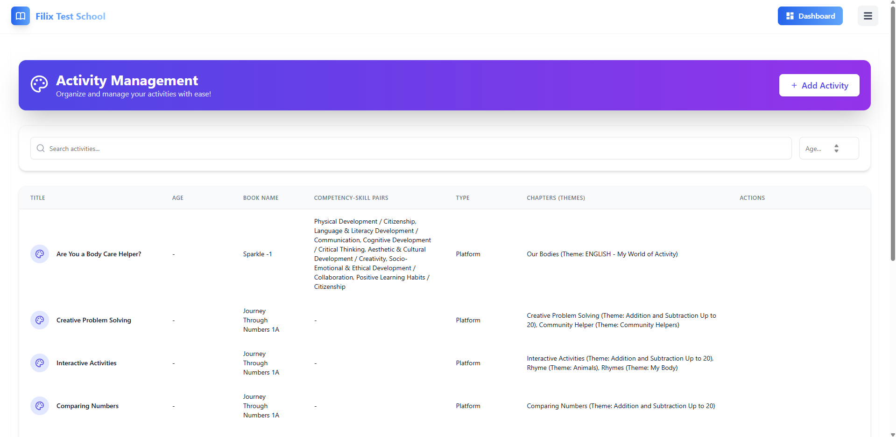

Overview
The Activity Management page is used to organize and manage all the activities in the system. It allows admins to easily track activities, assign them to specific classes or age groups, and link them to relevant competencies, skills, and chapters (themes). The page offers functionalities such as searching for activities, adding new ones, and viewing detailed information about each activity.

1. Activity List
The main section of the Activity Management page displays a list of all activities in the system. Each activity is shown with the following details:
- Title: The name of the activity (e.g., "Are You a Body Care Helper?").
- Age: The target age group for the activity.
- Book Name: The book associated with the activity (e.g., "Sparkle - 1").
- Competency-Skill Pairs: The competencies and skills linked to the activity (e.g., "Physical Development," "Language & Literacy Development").
- Type: The type of activity, which could be a platform-based activity or a different category.
- Chapters (Themes): The chapters or themes that are related to the activity (e.g., "Our Bodies (Theme: My World of Activity)").

2. Search and Filters
At the top of the Activity Management page, there are multiple search and filter options to help manage and locate activities quickly.
- Search Box:
  - Allows you to search for activities by name or title.
  - Type part of the title of the activity to quickly locate it.
- Filter Options:
  - Filter by Age and other criteria to narrow down the list of activities.

3. Add New Activity
On the top right of the page, you’ll find the Add New Activity button. This button opens a modal where you can input the details of a new activity.

Steps to Add a New Activity:
- Click the Add New Activity button to begin adding a new activity.
- Enter Activity Information:
  - Title: Enter the name of the activity (e.g., “Science Experiment”).
  - Description (Optional): Provide an optional description for the activity.
  - Class-Age Pairs:
    - Select the class associated with the activity.
    - Define the age group targeted by the activity.
  - Book Name: Select the book related to the activity from a dropdown list.
  - Chapters (Optional): Select the chapters that are associated with the activity.
  - School Status: Toggle between Private or Public visibility for the activity.

4. Competency-Skill Pairs
For each activity, you can define Competency-Skill Pairs, which helps specify the learning objectives and skills covered in the activity.
- Competency:
  - Select the competency related to the activity from a dropdown list.
- Competency Explanation:
  - Provide an explanation of the competency.
- Skill:
  - Select the skill associated with the activity.
- Skill Explanation:
  - Provide an explanation of the skill.
- Rubric:
  - Provide a description of how the activity will be assessed.

Adding More Pairs:
Click the Add Another Pair button to add more competency-skill pairs if needed.

5. Multimedia and Resource Links
The Activity Management page allows you to attach multimedia and resources to each activity:
- Video Links:
  - Add URLs for video links related to the activity. Multiple links can be added by separating them with commas.
- PDF Upload:
  - Attach relevant PDF files (up to 5MB). These could be instructions, worksheets, or reference materials for the activity.

6. Create the Activity
After filling out all the necessary fields:
- Click Create Activity to save the activity to the system.
- If you wish to discard the changes, click Cancel.

Conclusion
The School Admin Dashboard provides an efficient and user-friendly interface for managing various aspects of school operations. With a comprehensive set of tools, the admin can easily organize and track students, teachers, classes, cohorts, activities, chapters, themes, and student reports.
- Student Management: Admins can view and manage student details, assign them to specific cohorts, and generate reports to monitor their progress. The ability to search, filter, and view detailed reports makes managing the student roster a smooth process.
- Teacher Management: The dashboard enables admins to manage teacher licenses and assignments. The ability to add, view, and revoke teacher licenses ensures that the school’s teaching staff is well-organized.
- Class and Cohort Management: Admins have full control over class creation, cohort assignment, and monitoring. They can organize classes by year, section, and status, while tracking the number of active cohorts. Cohorts can be linked to specific themes and activities, ensuring that all learning modules are well-structured.
- Activity Management: Admins can create, manage, and track activities, ensuring they are correctly paired with age groups, themes, and competencies. The system allows for seamless integration of books, skills, and multimedia resources (e.g., video links, PDFs), providing a rich learning experience for students.
- Chapter and Theme Management: Admins have control over chapters and themes related to the curriculum. They can manage chapters, their associated activities, and the order of activities, ensuring that the content is effectively organized for each academic year.
- Reports and Analytics: The student report system provides insights into individual student progress, tracking competencies, skills, and activity history. Performance analytics help monitor progress over time, highlighting areas of strength and improvement for each student.

